Lesson 1 Homework | LT 3.3 | 1-15 odd, 16-18, 19-25 odd  DO ON SEPARATE SHEET OF PAPER

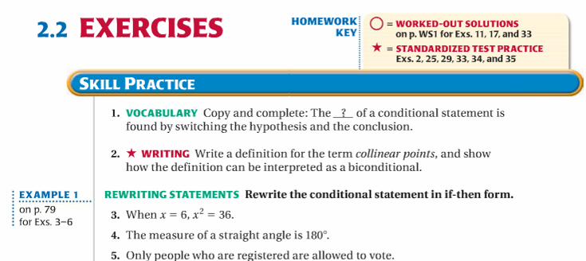

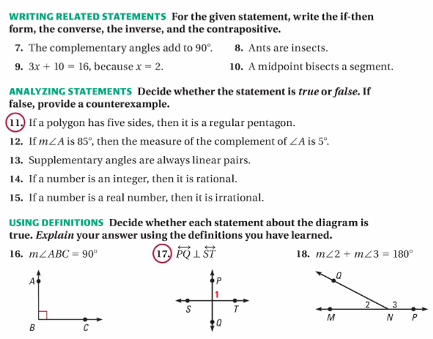

Lesson 1 Homework | LT 3.3 | 1-15 odd, 16-18, 19-25 odd  DO ON SEPARATE SHEET OF PAPER

